Project Design Phase-II
Data Flow Diagram & User Stories
Date | 31 January 2025
Team ID | Team-BMS-2025
Project Name | Bookstore Management System (MERN Stack)
Maximum Marks | 4 Marks

Data Flow Diagram
The diagram below is a Level-0 Data Flow Diagram (DFD) for the Bookstore Management System. It shows the external entities (Customer, Organizer, Admin, Payment Gateway), the core processes (catalog management, cart & checkout, order & inventory processing, reviews, and authentication), and the data stores (Users, Books, Orders, Reviews).
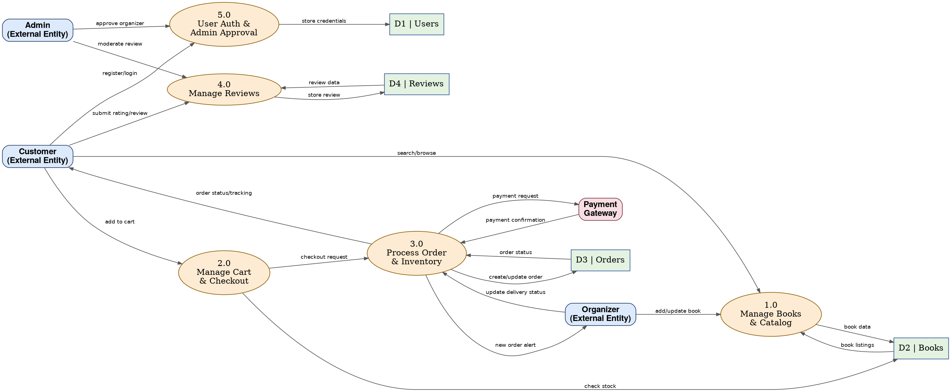

User Stories
The table below lists the user stories for each user type in the Bookstore Management System, grouped by functional requirement (epic), with acceptance criteria, priority, and target release.
User Type | Requirement (Epic) | Story # | User Story / Task | Acceptance Criteria | Priority | Release
Customer (Web/Mobile user) | Registration | USN-1 | As a user, I can register for the application by entering my name, email, mobile number, and password. | I can successfully create an account and access my dashboard | High | Sprint-1
 |  | USN-2 | As a user, I will receive a confirmation email once I have registered for the application. | I receive a confirmation email and can click to verify | High | Sprint-1
 |  | USN-3 | As a user, I can register for the application through Gmail. | I can register and access the dashboard using Gmail login | Medium | Sprint-1
 |  | USN-4 | As a user, I can register for the application through LinkedIn. | I can register and access the dashboard using LinkedIn login | Low | Sprint-2
 | Login | USN-5 | As a user, I can log into the application by entering my email and password. | I can log in and land on my personalized dashboard | High | Sprint-1
 | Book Discovery | USN-6 | As a user, I can search and filter books by title, author, genre, or category. | Relevant results are displayed with price, rating, and availability | High | Sprint-1
 | Cart & Checkout | USN-7 | As a user, I can add books to my cart and view the auto-calculated total. | Cart reflects correct items, quantities, and total price | High | Sprint-2
 |  | USN-8 | As a user, I can check out and pay using UPI, card, or cash on delivery. | Payment is processed and an order confirmation is shown | High | Sprint-2
 | Order Tracking | USN-9 | As a user, I can view my order history and track the current delivery status. | My Orders page shows status: Pending, Processing, Shipped, Delivered | High | Sprint-2
 | Reviews | USN-10 | As a user, I can rate and review a book after it has been delivered. | My review and star rating appear on the book's detail page | Medium | Sprint-3
Organizer | Dashboard | USN-11 | As an organizer, I can log in to a dedicated dashboard to manage my listings. | I see my inventory and customer orders after logging in | High | Sprint-2
 | Inventory Management | USN-12 | As an organizer, I can add a new book with price, stock, and description. | The new book appears in the public catalog after saving | High | Sprint-2
 |  | USN-13 | As an organizer, I can update pricing and stock levels for existing books. | Updated values are reflected immediately in the catalog | Medium | Sprint-3
 | Order Processing | USN-14 | As an organizer, I can update the delivery status of orders containing my books. | Customers see the updated status on their My Orders page | High | Sprint-3
Administrator | Organizer Approval | USN-15 | As an admin, I can review and approve or reject new organizer registrations. | Approved organizers gain dashboard access; rejected ones are notified | High | Sprint-3
 | User Management | USN-16 | As an admin, I can view, suspend, or delete user and organizer accounts. | Account status changes take effect immediately across the platform | Medium | Sprint-3
 | Review Moderation | USN-17 | As an admin, I can moderate or remove reported reviews. | Removed reviews no longer appear on the book's detail page | Medium | Sprint-4
Customer Care Executive | Order Support | USN-18 | As a customer care executive, I can look up any customer's order to help resolve delivery issues. | I can view full order and delivery details by order ID or customer email | Low | Sprint-4

